Systemic redox status and tracheal aspirate phospholipid metabolism is unaltered in mechanically ventilated patients receiving oxygen with conservative versus usual oxygen targets- a mechanistic sub study of UK-ROX RCT

Ahilanandan Dushianthan^{1,2,3}, Daniel Martin^{4,5}, Magdalena Minnion², Madhuri Panchal² , Grielof Koster², Sara Navalesi¹, Susan Jackson¹, Helen Moyses², Florence Neyroud¹, Paul Mouncey⁶, Tasnin Shahid⁶, Lamprini Lampro⁶, Amelia F Johnson⁶, Victoria Goss⁷, Angelica Cazley⁷, William Herbert⁷, Kelly Chung⁸, Mark Lamond⁸, Mark Brown^{1,2,3}, Karen Salmon^{1,2}, Julian Lentaigne⁷, Dermot Linden⁸, Danny F McAuley⁸, Kordo Saeed^{1,9}, Martin Feelisch^{2,3}, Anthony D Postle^{2,3} Michael P W Grocott^{1,2,3}
Author Affiliations
- General Intensive Care Unit, University Hospital Southampton NHS Foundation Trust, Southampton, UK
- University Hospital Southampton NIHR Biomedical Research Centre, Southampton, UK.
- Faculty of Medicine, University of Southampton, Southampton, UK.
- Peninsula Medical School, University of Plymouth, John Bull Building, Plymouth, UK
- Department of Intensive Care, University Hospitals Plymouth, Plymouth, UK
- ICNARC, London, UK
- Clinical Trials Unit (CTU), University Hospital Southampton NHS Foundation Trust, Southampton, UK
- Patient advisory group, University Hospital Southampton NHS Foundation Trust, Southampton, UK
- Wellcome-Wolfson Institute for Experimental Medicine, School of Medicine, Dentistry & Biomedical Sciences, Queen’s University Belfast, BT9 7BL, Northern Ireland, UK
- Microbiology Department, University Hospital Southampton NHS Foundation Trust, Tremona Road, Southampton, UK
*Corresponding Author
Dr Ahilanandan Dushianthan
General Intensive Care Unit, University Hospital Southampton NHS Foundation Trust
Tremona road, Southampton, SO16 6YD, UK.
a.dushianthan@soton.ac.uk

Abstract

Background
MecROX is a mechanistic sub-study of the UK-ROX randomised controlled trial, which compared conservative with usual oxygen saturation targets in mechanically ventilated adults in intensive care. Hyperoxemia has been proposed to affect alveolar surfactant composition and metabolism and increase systemic oxidative stress, which has not been evaluated in the context of oxygen target trials. The aim of the study to determine the effects of oxygen targets on lung surfactant phospholipid composition, synthesis, and systemic redox status.

Methods
Mechanically ventilated adults with hypoxemic respiratory failure were recruited from two UK centres (Southampton and Plymouth) after enrolment into UK-ROX. 3 mg/kg methyl-D₉-choline chloride was administered (a stable isotope to trace surfactant synthesis), blood and endotracheal aspirate (ETA) samples were collected at baseline, 48 and 72 hours. Surfactant phospholipid composition along with systemic redox status was assessed using markers of antioxidant capacity, lipid oxidation, nitrosative stress, and thiol/sulfur metabolism. Between-group comparisons were adjusted for baseline values.

Results
Sixty-five patients included in the analysis (conservative n=30, usual n=35). There was a sustained ~2.5% SpO₂ difference between groups from the time of intervention initiated. There were no differences in the primary outcome, ETA PC32:0 composition, at 48 hours. There were also no differences in surfactant index, total PC concentration, or methyl-D₉ enrichment of PC32:0 (surfactant synthesis) or lysophosphatidylcholine (surfactant breakdown) at either 48 or 72 hours. Measures of systemic redox status were similarly unchanged between groups.

Conclusion
There were no differences in surfactant phospholipid composition, metabolism or systemic redox status between patients managed with a conservative SpO₂ target (~92%) and those with usual oxygen targets (~94%) over the first 72 hours. These mechanistic findings are consistent with the clinical results of UK-ROX and suggest that the modest difference in oxygen exposure between the treatment groups did not measurably influence surfactant metabolism or systemic redox biology. The findings should not be extrapolated to higher oxygen targets.

Keywords
Oxygen
Hyperoxia
Mechanical ventilation
Surfactant
Redox
Oxidative stress

Introduction
Mechanically ventilated patients in the intensive care unit (ICU) often need supplemental oxygen to optimise hypoxemia. UK-ROX randomised controlled trial (RCT) recently investigated the clinical effectiveness of a conservative oxygen therapy approach to achieve a low oxygen saturation target (SpO₂ 90±2%) compared with standard therapy in mechanically ventilated patients¹. The MecROX is a sub-study of the UK-ROX RCT to evaluate systemic redox status and dynamic surfactant biology following the two different oxygen therapy approaches in mechanically ventilated patients².
In animal models exposure to hyperoxia is associated with alterations in pulmonary surfactant metabolism leading to the development of acute lung injury^{3,4}. Pulmonary surfactant is a complex lipoprotein mixture essential for the maintenance of alveolar stability and consists primarily of phospholipids, of which 80-85% is phosphatidylcholine (PC), with dipalmitoyl-PC (DPPC) or PC32:0 accounting for 40-60% and proteins⁵. Anionic phospholipids (such as phosphatidylglycerol (PG), phosphatidylinositol (PI), phosphatidylserine (PS) and phosphatidylethanolamine (PE)) and neutral lipids such as sphingomyelin account for the remainder. DPPC is the primary essential PC molecule required for the surface reduction property of surfactant. Lungs are the primary target for direct oxygen toxicity, and animal studies have consistently demonstrated that lungs exposed to high oxygen concentrations exhibit quantitative and qualitative alterations in surfactant phospholipid and protein composition, metabolism and function⁶.

Moreover, hyperoxemia can increase systemic oxidative stress and deplete redox storage. This imbalance of increased oxidative stress and reduced redox storage generated by hyperoxemia can result in exhaustion of antioxidant mechanisms, exacerbating tissue damage⁷. The complex interplay between reactive oxygen species (ROS), reactive nitrogen (RNS) and sulphur-based species (RSS) can be detailed by the conceptual framework of the “reactive species interactome (RSI)” which describes the chemical interaction between these highly reactive molecules and their downstream intracellular targets and metabolites contributing to organ dysfunction⁸.

However, there remains a lack of understanding of hyperoxemia-related organ damage from in vivo human studies. We hypothesise that systemic hyperoxemia may increase systemic oxidative stress and adversely impact dynamic systemic redox biology and lung surfactant metabolism. The primary aim of this study is to characterise in-depth the alveolar surfactant biology, oxidative stress and whole-body redox status in mechanically ventilated adult patients receiving two different oxygen therapy strategies by exploring dynamic surfactant phospholipid composition, synthesis, and oxidative catabolism in vivo and systemic oxidative stress and redox status by measuring the ‘reactive species interactome’.

Methods and analysis

Study design
The MecROX is a prospective sub-study of the UK-ROX RCT^{1,2}. Participants were recruited from two centres (University Hospital Southampton and University Hospitals Plymouth) which recruited patients into the UK-ROX RCT. After enrolment into the UK-ROX trial, patients were randomised to either conservative or standard oxygen therapy targets. The MecROX study enrolled mechanically ventilated UK-ROX participants due to hypoxaemic respiratory failure. The oxygen saturation (SpO₂) targets for both groups are detailed below.
Conservative oxygen target: For the conservative group, the lowest concentration of oxygen will be administered to maintain the patient’s SpO₂ at 90 ±2% (i.e., for patients receiving oxygen this should not rise above 92%). Usual oxygen target: This is defined as local practice as determined by treating clinicians.

Study regulations and consent process
The study is sponsored by the University Hospital Southampton NHS Foundation Trust and approved by HRA and the London Bromley Research Ethics Committee, REC: 22/LO/0877 and IRAS: 320671. The study is registered on ISRCTN registry, ISRCTN61929838 (https://doi.org/10.1186/ISRCTN61929838). The MecROX study is managed by the Southampton Clinical Trials Unit (CTU). The study was funded by the National Institute for Health and Care Research (NIHR) Efficacy and Mechanism Programme (EME). Once patients were recruited into the UK-ROX trial by a deferred consent model within 12 hours after fulfilling the eligibility criteria, for the MecROX sub-study a patient informed deferred consent from a personal consultee opinion was sought within 24-48 hours and when the participant regained capacity to consent, a retrospective consent was obtained.

Interventions

Methyl-D₉ choline infusion
Choline is a crucial component of the lung surfactant PC. Labelling naturally occurring choline (methyl-D₉ choline chloride) with a non-toxic, non-radioactive, stable isotope of hydrogen (deuterium, D) helps measure the rate of surfactant PC synthesis and breakdown^{9,10}. Methyl-D₉-choline chloride was in water at 10 mg/ml and infused at a dose of 3 mg/kg body weight (maximum 300mg) over 3 hours. The incorporation of methyl-D₉ choline chloride into PC via CDP-choline pathway and subsequent hydrolysis via phospholipase A2 (PLA2) into lysophosphatidylcholine (LPC) is presented as figure 1.
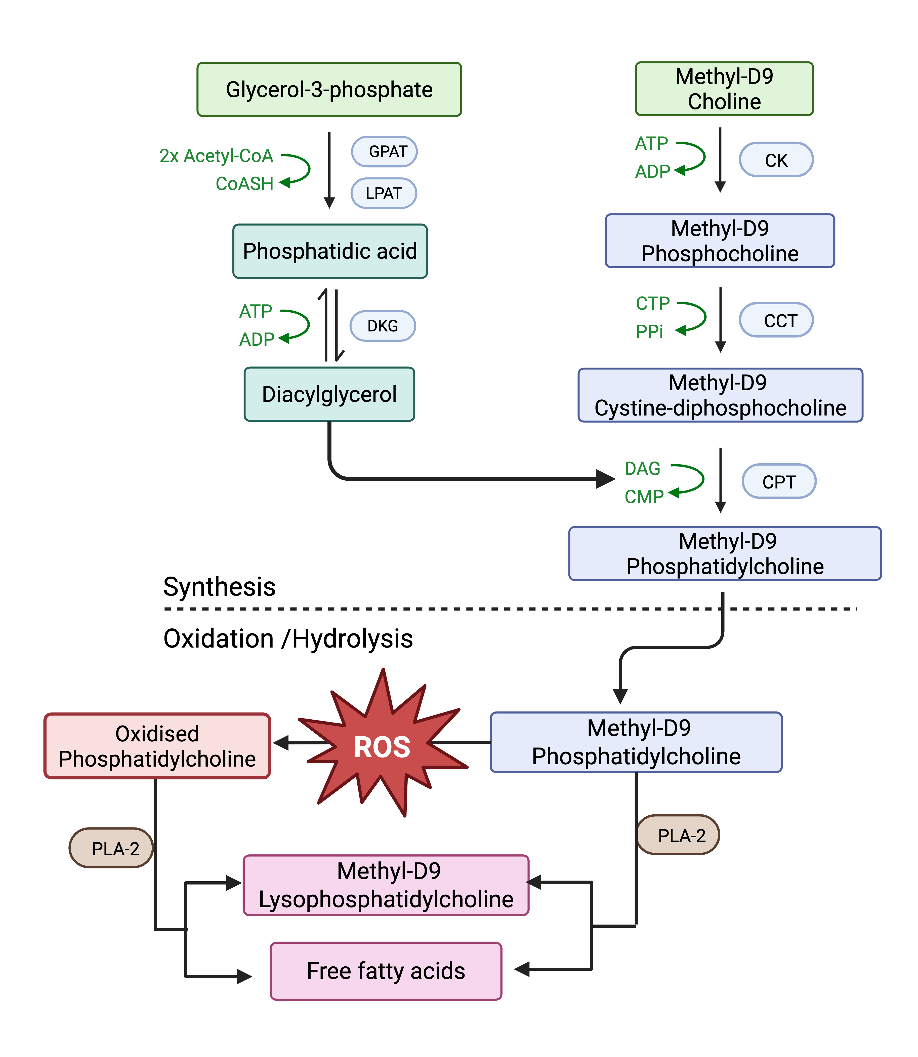
Figure 1: Surfactant PC synthesis via CDP-choline pathway. The incorporation of Methyl-D₉ choline chloride help trace surfactant PC synthesis and breakdown by phospholipase A2 into Lysophosphatidylcholines. ADP, adenosine diphosphate; ATP, adenosine triphosphate; m CK, choline kinase; CCT, CTP: phosphocholine cytidylyltransferase; CMP, cytidine monophosphate, DAG, diacylglycerol; DKG, Diacylglycerol kinase; GPAT, Glycerol-3-phosphate acyltransferase; PLA2, Phospholipase A2; ROS, reactive oxygen species.

Blood and tracheal aspirate samples collection and processing
EDTA (10 ml) blood samples will be taken at baseline (T=0), 48, and 72 hours, (while in ICU) after the methyl-D₉-choline infusion. Endotracheal aspirates (ETA) were also taken at 0, 48, and 72 hours, after the methyl-D₉-choline infusion. The ETA samples were collected by blind suctioning by an endotracheal suction catheter introduced through a port into the endotracheal tube. Blood samples collected from the study participant were subjected to centrifugation at 1200xg for 10 min and plasma was aliquoted and frozen at -80⁰C. ETA samples will be taken into pre-labelled tissue culture (Falcon) tubes and stored at +4ºC in the ICU sample fridge until transfer to the laboratory for processing.
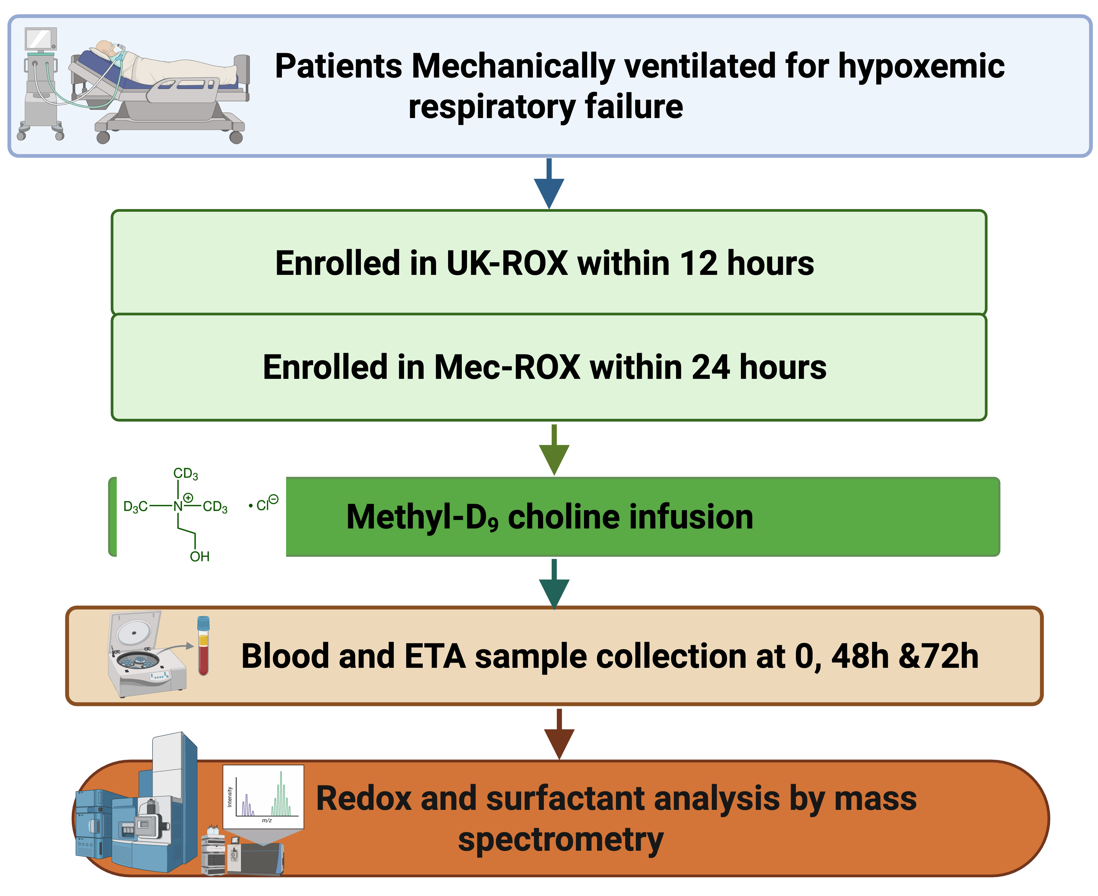
Figure 2: Study flow chart and sampling schedule.

Sample analysis

Tracheal aspirate surfactant lipid composition and dynamic turnover

Phospholipid Extraction
Total lipids from TA samples were extracted using the Bligh and Dyer protocol¹¹. Samples were thawed at room temperature and, when necessary, their volume was adjusted to 800 µL using 0.9% saline. An internal standard consisting of 10 µL SPLASH® LIPIDOMIX® (Avanti Polar Lipids, USA) was added to each sample to allow phospholipid quantification. In addition, 10 µL BHT solution was added as an antioxidant. Samples were vortex-mixed, and lipid extraction was performed using a Freedom EVO 100 robotic liquid-handling system (Tecan, Theale, UK), processing batches of 24 samples. The extraction program added 2 mL methanol, 2 mL dichloromethane (DCM), and 1 mL distilled water to each tube. After thorough mixing, a biphasic system formed, with phospholipids partitioning into the lower DCM layer. Samples were centrifuged at 1500 rpm, 20 °C for 10 minutes, and the robotic system removed the lower lipid phase. The collected lipid extracts were dried under a stream of warmed nitrogen using an Ultravap evaporator (Porvair, Norfolk, UK) for 40 minutes. Dried extracts were stored at –20 °C until analysis.

ESI-MS/MS Analysis of surfactant phospholipids
Dried lipid extracts were re-suspended in in 350µl 66% methanol, 30% DCM, 3% H20 and 1% concentrated ammonia solution (NH4OH) and injected directly into the electrospray ionisation interface of a XEVO-TQS mass spectrometer (Waters Corporation, UK, ESI-MS/MS) at 10µl/min. MS/MS precursor ion scans identified unlabelled phosphatidylcholine (PC), lysophosphatidylcholine (LPC) and sphingomyelin (SM) (m/z 184+), phosphatidylglycerol (PG) (m/z 153-), phosphatidylinositol (PI) (m/z 241-) and methyl-D9 labelled PC, LPC and SM (m/z 193+). Neutral loss scans identified phosphatidylinositol (PE) (m/z 141+) and phosphatidylserine (m/z 87-). Mass spectrometry data exported from MassLynx 4.1 (Waters Corporation, UK) was processed by an in-house programme. Initially, MS spectra were smoothed, baseline subtracted and exported to individual Excel files. These files were then imported into the macro program and corrected for ¹²C or ¹³C isotopic effects.

Quantification of systemic redox markers
Samples were analysed for the following redox markers: Total Free Thiols (TFT), Thiobarbituric Acid Reactive Substances (TBARS), Ferric Reducing Ability of Plasma (FRAP), nitroso species (RXNO), nitrite and nitrate (NOx), thiol metabolome, sulfate, thiosulfate, and protein. Nitrite (NO₂) and nitrate (NO₃⁻) concentrations were quantified using a dedicated high-performance liquid chromatography system (ENO-30, Eicom) as described elsewhere¹². Total nitroso species (RXNO) content was assessed by gas phase chemiluminescence detection of NO (CLD 88 sp, ECO Medics) following removal of nitrite and reduction of plasma aliquots with acidic triiodide¹³ Ultrahigh performance liquid chromatography tandem mass spectrometry (UPLC-MS/MS, Aquity Xevo TQ-S, Waters) was utilized to separate and quantify sulfide and free reduced and oxidized aminothiols including glutathione (GSH), cysteine (CyS) and homocysteine (Hcy) following derivatisation with N-ethylmaleimide. The levels of total thiols (comprising free reduced and oxidized as well as protein-bound forms) were determined following reaction with dithiothreitol. Details on incubation conditions, chromatography and mass spectrometry parameters were described by our group previously¹⁴.
Sulfate and thiosulfate concentrations were determined by ion chromatography mass spectroscopy (IC-MS; Dionex ICS-5000 with ISQ EC, ThermoScientific). Sulfate and thiosulfate are identified using the appropriate mass/charge ratio (m/z 97.1 for sulfate and m/z 113.0 for thiosulfate) and retention time (3.67 min for sulfate and 5.07 min for thiosulfate) and quantified using external calibration standards. The remaining markers (TFT, TBARS, FRAP and protein) were measured spectrophotometrically. TFT was determined using Ellman’s reagent¹⁵. Detection of lipid oxidation was established by measuring the level of malondialdehyde (MDA) reacting with thiobarbituric acid¹⁶. Antioxidant capacity of plasma was assessed by its ability to reduce ferric ions (Fe³⁺) to ferrous ions (Fe²⁺) using assay conditions described elsewhere¹⁷. Plasma protein concentration was quantified using the Pierce Bradford Protein Assay Kit (ThermoFisherScientific, s/n 23200).

Baseline data, primary and secondary outcomes
The baseline clinical data included standard demographics including age, gender, BMI, comorbidities, APACHE II score and SOFA scores. The primary outcomes in the comparison of PC32:0 composition between groups and secondary outcomes included the comparison of surfactant index- a composite of surfactant specific PC molecules (PC32:0, PC32:1 and PC30:0) and unsaturated surfactant PC (PC34:1) (PC32:0+PC32:1+PC30:0)/PC34:1, total surfactant PC concentration at 48 hours, total PC and PC32:0 methyl-D₉ choline enrichment at 48 and 72 hours, total LPC and lysoPC16:0 concentrations compositions and methyl-D₉ enrichment at 48 hours. The secondary outcomes included other surfactant phospholipid variables and systemic redox markers at 48 and 72 hours².

Statistical analysis
Descriptive statistics were used to summarise baseline demographic and clinical variables. For continuous variables, the mean and standard deviation or median and interquartile range are presented, depending on Normality. Categorical and binary variables are summarised as frequency and percentage of total. For the primary outcome, a multiple regression model was used to compare conservative versus usual care at 48 hours, adjusted for baseline. This was repeated for the secondary outcomes of surfactant index and surfactant phosphatidylcholine concentration. For non-Normally distributed, right-skewed variables, the log transformation was used. For redox variables, where appropriate, repeated measures mixed models were used to investigate differences between treatment groups over all timepoints, otherwise the Wilcoxon-Mann-Whitney test was performed at each timepoint.
Percentage compositions, concentrations of ETA phospholipids are calculated relative to the internal standards and label enrichments were then analysed in GraphPad Prism 10.0 and presented as means and either standard deviation or standard error. The SpO₂ was measured from validated oxygen targets every hour and then locally weighted scatterplot smoothing (LOWESS) curves were used to describe SpO₂ and time since randomisation between treatment groups.

Results

Participant characteristics
There were 67 participants recruited from the UK-ROX trial. Two refused subsequent consent, resulting in 65 mechanically ventilated patients, conservative N=30 and usual target N=35, for further mechanistic analysis (Fig 3). The median age was 58 (51,73) and 63 (50,79) and respectively. There were imbalances between groups with more patients in conservative group had chemotherapy (p=0.005) and asthma (p=0.017). There were no other statistical differences in baseline demographics between the groups. The details of the demographics are presented in table 1.
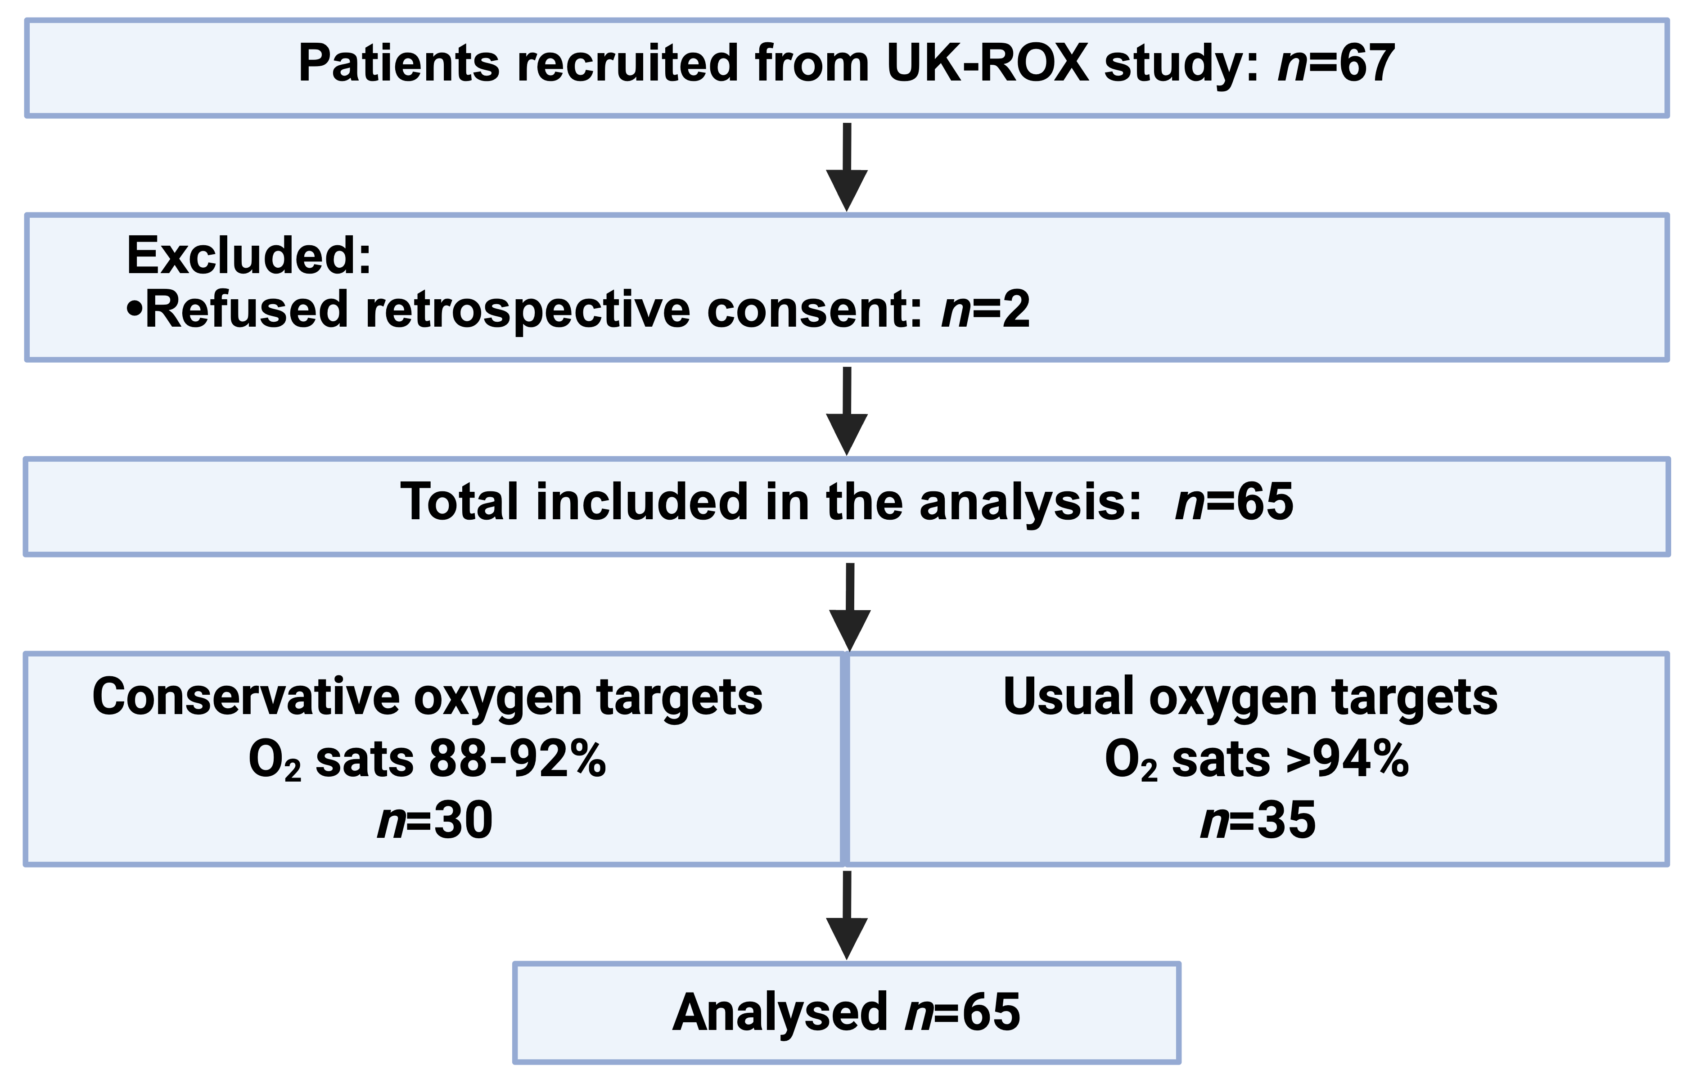
Figure 2: PRISMA study flow chart
 | Usual Care | Conservative | p-value
 | N=35 | N=30
Age | 63 (50, 79), n=33 | 58 (51, 73), n=29 | 0.494
Sex (% male) | 21/33 (64%) | 13/29 (45%) | 0.138
BMI | 27 (25, 32), n=33 | 26 (22, 29), n=29 | 0.354
Chemotherapy | 1/33 (3%) | 8/28 (29%) | 0.005
APACHE II score | 16 (14, 23), n=33 | 20 (16, 23), n=29 | 0.299
SOFA (0-2 per organ) | 6 (5, 7), n=33 | 5 (4, 7), n=29 | 0.612
SOFA (0-4 per organ) | 7 (6, 10), n=33 | 7 (4, 11), n=28 | 0.865
Clinical frailty score | 3.5 (2, 5), n=30 | 3 (3, 4.5), n=28 | 0.933
Hypertension | 8/30 (27%) | 10/28 (36%) | 0.457
Diabetes | 8/30 (27%) | 5/28 (18%) | 0.421
Chronic kidney disease | 2/30 (7%) | 3/28 (11%) | 0.583
Asthma | 1/30 (3%) | 7/28 (25%) | 0.017
COPD | 5/30 (17%) | 8/28 (29%) | 0.277
Cardiovascular disease | 4/30 (13%) | 5/28 (18%) | 0.634
Cirrhosis | 2/30 (7%) | 1/28 (4%) | 0.595
Immunosuppression | 2 /30 (7%) | 3/28 (11%) | 0.583
COVID-19 | 4 (11%) | 2 (7%) | 0.508
Sepsis | 7 (20%) | 9 (30%) | 0.351
Acute brain injury | 1 (3%) | 1 (3%) | 0.912

Table 1: Baseline demographics. APACHE, acute physiology and chronic health evaluation score; BMI, body mass index; COPD, chronic obstructive pulmonary disease; COVID-19, coronavirus disease 2019; SOFA, sequential organ specific assessment score.

Oxygen saturation separation between groups
Once recruited into the UK-ROX trial, patients were randomised to either conservative or usual oxygen targets. Detailed oxygen saturation data was available for 58 patients (89%) from pre-randomisation and at baseline. There was a clear separation of oxygen saturation targets between groups SpO₂ of 2.5±0.5% between groups. The details of the oxygen saturation separation are presented as table and figure.
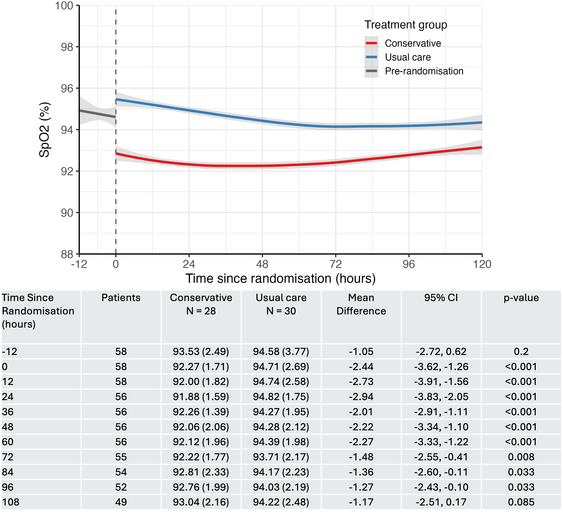
Figure 3: Peripheral oxygen saturation (SpO₂) from time since randomisation between treatment groups. Pre-randomisation included all patients from 12 hours before randomisation. Locally weighted scatterplot smoothing (LOWESS) was used to describe non-linear trends. Table of patient-level averages summarised every 12 hours from time since randomisation and between treatment groups. Differences were assessed with Welch’s two-sample t-test.

Endotracheal aspirate phospholipid composition
The phospholipid fraction extracted from the ETA consisted of phosphatidylcholines (PC), phosphatidylethanolamine (PE), phosphatidylserine (PS), phosphatidylinositol (PI), sphingomyelin (SM), phosphatidylglycerol (PG) and lysophosphatidylcholine (LPC). The fractional composition of the phospholipid fraction is presented as pictorial figure (Fig 4). There were no differences in the individual phospholipid fractions between conservative and usual groups.
Figure 4: Pictorial view of the fractional phospholipid composition within the ETA lipidomic analysis. A-C: conservative group (A, T=0, B, T=48 and C, T=72 hours) and D-F: usual group (D, T=0, E, T=48 and F, T=72 hours). Results are presented as median mol%. There was no statistical difference between the groups.
Of those 65 participants, 62 patients had tracheal aspirate samples taken and analysed at baseline. As expected, the ETA phospholipid composition consisted of PC, and the principal PC involved in surface reduction, PC32:0 predominates (26.3%). However, this was much lower proportion in comparison to healthy humans (~50%)⁵. There was no difference in the composition of PC32:0 between both groups and there were no changes overtime following the initiation of intervention (primary outcome). Similarly, there were no differences in the calculated surfactant index or total selected PC concentrations between groups and over time.
 | Time | Usual | Conservative | Difference  (95% CI)∗ | p-value
PC32:0  (% of total PC) | 0  48  72 | 26.3 (12.3), n=32  27.0 (10.8), n=27  24.4 (9.8), n=19 | 25.9 (11.6), n=30  25.7 (12.9), n=22  24.5 (11.9), n=19 | 0.93  (-3.92, 5.77) | 0.702
Surfactant index (PC30:0+PC32:1+PC32:0)  PC34:1 | 0  48  72 | 2.1 (1.5), n=32  2.0 (0.9), n=27  2.0 (0.9), n=19 | 2.0 (1.1), n=30  2.0 (1.2), n=22  2.2 (1.5), n=19 | 0.09  (-0.42, 0.61) | 0.712
log (surfactant total PC concentration) | 0  48  72 | 2.2 (1.5), n=32  2.0 (1.2), n=27  1.5 (1.9), n=19 | 2.1 (1.6), n=30  1.9 (1.2), n=22  2.3 (1.5), n=19 | -0.10  (-0.76, 0.55) | 0.754

Table 2: The surfactant phospholipid outcomes comparison between both groups. *Comparing conservatives vs. usual care at 48 hours, adjusted for baseline (T=0 hours).

The ETA molecular PC composition mainly consisted of PC32:0 (26.7%), PC34:1 (20.0%), PC34:2 (8.9%), PC36:2 (7.9%) and PC32:1 (6.8%). There were no differences between PC composition between two groups and the principal PC PC32:0, there were no changes over time. The dynamic flux of PC synthesis and breakdown as investigated by the enrichment of methyl-D₉ choline chloride. At 48 and 72 hours the total PC and PC32:0 % enrichment (newly synthesised fraction) was similar between groups, suggesting the endogenous synthesis and secretion of overall PC and surfactant specific PC (PC32:0) were similar between those with conservative and usual targets.

Figure 5: Endotracheal aspirate phosphatidylcholine composition (A), PC32:0 composition (B), total methyl-D₉ incorporation and selective PC32:0 methyl-D₉ incorporation (D), comparison between conservative and usual groups.

Systemic redox markers
We measured stable systemic redox markers to evaluate the reactive species interactome. These redox biomarkers were grouped into six categories according to their mechanism: (1) global antioxidant capacity (TFT and FRAP); (2) oxidative lipid injury (TBARS); (3) nitric oxide and nitrosative stress (nitrite, nitrate and RXNO); (4) thiols (GSH, GSSG, cysteine, cystine, homocysteine, and homocystine); and (5) sulfide metabolism and sulfur oxidation (sulfide, thiosulfate and sulfate). Collectively, these biomarkers provide a comprehensive assessment of oxidative stress, antioxidant defence, nitrosative signalling and sulfur-redox metabolism. There were no differences in these redox markers between conservative and usual groups at 48 or 72 hours (Table 3).
Category | Redox marker | Time | Coefficient (95% CI)
- Global antioxidant capacity | Total free thiols (TFT)- systemic extracellular redox buffer,  TFT, μM  FRAP- plasma antioxidant system  log (FRAP, μM) | 0  48  72  0  48  72 | 11.35(-17.41, 40.10), p=0.439  17.30(-12.47, 47.07), p=0.255  13.07(-17.00, 43.13), p=0.394  -0.02 (-0.23, 0.19), p=0.828  0.01 (-0.21, 0.22), p=0.953  0.03 (-0.18, 0.25), p=0.755
- Oxidative lipid injury | TBARS- marker of oxidative damage of lipids  log (TBARS, nM) | 0  48  72 | 0.03 (-0.23, 0.28), p=0.830  -0.06 (-0.31, 0.19), p=0.624  0.04 (-0.22, 0.31), p=0.747
- Nitric oxide and nitrosative stress | Nitrite (NO₂⁻)- stable oxidation product of NO  log (nitrite, μM)  Nitrate (NO₃⁻)- terminal oxidation product of NO  log (nitrate, μM)  RXNO- nitrosated compounds formed by reaction with NO and thiols, nM | 0  48  72  0  48  72  0  48  72 | 0.06 (-0.37, 0.48), p=0.783  0.35 (-0.12, 0.83), p=0.143  0.25 (-0.23, 0.73), p=0.303  -0.07 (-0.40, 0.27), p=0.691  -0.11 (-0.53, 0.32), p=0.609  0.04 (-0.39, 0.46), p=0.864  p=0.563  p=0.977  p=0.793
- Glutathione pathway and thiol metabolism | Free GSH- reduced glutathione, major intercellular antioxidant,  log (free GSH, nM)  Free GSSG- oxidised glutathione, log (free GSSG, nM)  Total GSH- combined reduced and oxidised glutathione reflects total glutathione reserve,  log (total GSH, μM)  Free Cysteine (Cys)- precursor for glutathione synthesis  log (free Cys, nM)  Free Cystine (CySS)- oxidised form of Cys, marker of extracellular oxidative, log (free CySS, nM)  Total Cys- total cysteine reservoir, reflect sulfur amino acid availability log (total Cys, μM)  Free Homocysteine (HCyS)- intermediate linking methylation and trassulfuration pathways  log (free HCyS, nM)  Free Homocystine (HyCSS)- oxidised form of HCyS, marker of HCyS oxidation, log (free HyCSS, nM)  Total HCyS- total homocysteine pool, reflect one carbon metabolic activity log (total HCyS, μM) | 0  48  72  0  48  72  0  48  72  0  48  72  0  48  72  0  48  72  0  48  72  0  48  72  0  48  72 | 0.05(-0.46, 0.55), p=0.849  -0.08(-0.62, 0.46), p=0.766  0.40(-0.19, 0.99), p=0.175  0.15(-0.40, 0.71), p=0.581  0.20(-0.26, 0.67), p=0.385  0.17(-0.26, 0.60), p=0.430  0.08(-0.45, 0.61), p=0.769  0.05(-0.48, 0.58), p=0.855  -0.07(-0.60, 0.46), p=0.796  -0.05(-0.44, 0.35), p=0.816  -0.02(-0.60, 0.55), p=0.936  0.11(-0.40, 0.63), p=0.657  0.08(-0.23, 0.40), p=0.593  0.04(-0.28, 0.35), p=0.820  -0.15(-0.54, 0.24), p=0.444  -0.03(-0.24, 0.18), p=0.797  -0.09(-0.31, 0.13), p=0.424  -0.05(-0.23, 0.12), p=0.551  0.10(-0.50, 0.70), p=0.739  -0.25(-0.67, 0.17), p=0.236  0.01(-0.63, 0.65), p=0.971  -0.22(-0.75, 0.31), p=0.407  -0.30(-0.93, 0.34), p=0.355  0.21(-0.47, 0.90), p=0.535  0.04(-0.27, 0.36), p=0.779  -0.03(-0.32, 0.27), p=0.858  0.10(-0.19, 0.40), p=0.495
- Sulfur oxidation pathways | Free sulfide (H₂S)- bioactive gasotransmitter involved in signalling pathways.  Log (free sulfide, μM)  Sulfate- final oxidation product of sulfur metabolism, μM  Thiosulfate – intermediate metabolite during mitochondrial oxidation of H₂S, nM | 0  48  72  0  48  72  0  48  72 | -0.08(-0.70, 0.54), p=0.792  0.20(-0.38, 0.78), p=0.496  0.30(-0.28, 0.89), p=0.303  p=0.956  p=0.789  p=0.073  p=0.391  p=0.096  p=0.262
Table 3: systemic redox markers comparison between conservatives and usual groups. Results of repeated measures mixed models. For variables where a p-value is presented with no estimate, mixed models were not appropriate, so the results of the Wilcoxon-Mann-Whitney test at each timepoint is presented.

Discussion
MecROX is a two-centre mechanistic study of the UK-ROX randomised controlled trial. We compared the systemic redox markers and ETA molecular phospholipids across both groups following an intervention period of 48 and 72 hours. There was a separation of ~2.5% difference in the oxygen saturation targets between groups. This separation in oxygen targets did not produce any differences in the fractional phospholipid content, phosphatidylcholine composition, concentrations and dynamic turnover until 72 hours after the initiation of UK-ROX intervention. Our study demonstrated that the conservative approach of lower oxygen targets of 65 mechanically ventilated patients did not produce any significant biological changes in the ETA surfactant lipid composition and metabolism and systemic redox biology.
Previous human studies have demonstrated that supplemental oxygen and hyperoxia can increase systemic and pulmonary markers of increased oxidative stress, including lipid peroxidation products, protein oxidation and depletion of antioxidant defences¹⁸⁻²¹. However, detailed mechanistic data linking oxygen exposure by peripheral oxygen targets to surfactant phospholipid metabolism and redox biology in mechanically ventilated critically ill adults remain scarce. To our knowledge, this is the first mechanistic study to evaluate surfactant phospholipid metabolism and detailed redox biology embedded within a randomised oxygen-target trial. However, exploring the separation targets, the study only evaluated normoxaemia (94%), versus relative hypoxemia (92%), rather than hyperoxemia.
Lung surfactant complex consists of a mixture of phospholipids (90%) proteins (10%) and the phospholipids are vulnerable to oxygen therapy and hyperoxia⁶. However, we did not detect any changes in overall phospholipid content or individual phospholipid classes and molecular species within 72 hours of intervention with ~2.5% difference in oxygen targets. In our population, the overall phospholipid content is lower than previously documented quantitative lavage measurements in healthy population or ARDS. Moreover, the distribution of phospholipid classes is also different from heathy people, with fractional reductions in PC and PG with increases in PE, PI, PS and SM¹⁵. This is likely reflective of increased inflammatory material contribution from cellular membrane than surfactant phospholipids. The PC contribution is much lower and the PC32:0 (principal PC involved in surface tension reduction is <30% suggesting the abnormal fractional phospholipid composition. The PG which is involved in surfactant spreading and immunomodulatory function was also much lower, consistent with the previous studies on ventilated pneumonia, ARDS and COVID-19 patients^{16,17,18}. This suggests that despite no differences between groups, there are significant abnormalities in surfactant phospholipid composition and fractional molecular distribution in these mechanically ventilated patients likely reflecting the endogenous disease process. Methyl-D₉ choline incorporation was used to measure endogenous synthesis of surfactant PC. This demonstrates no difference in the total PC and PC32:0 methyl-D₉ choline incorporation between the groups, suggesting there are no difference in surfactant PC synthesis between the groups. Surfactant PC is hydrolysed by secretary phospholipase A₂ (PLA2) to LPC and free fatty acids (Fig 1).
While oxygen therapy is essential for critically ill mechanically ventilated patients, there are potentially many harmful effects from hyperoxia and hyperoxemia, as demonstrated by several studies of hospitalised patients with acute conditions²⁶. While oxygen toxicity due to hyperoxia or hyperoxaemia is a well-recognised phenomenon in animal studies, this study only evaluated the effect of normoxaemia (SpO₂~94%) versus relatively modest conservative SpO2 target of 92%. In-vivo human models evaluating hyperoxia-induced organ damage in mechanically ventilated patients are lacking. While these findings provide reassurance that modest conservative SpO₂ targets of around 92% are not associated with measurable changes in systemic redox biology or lung surfactant phospholipid composition and metabolism, consistent with the UK-ROX trial, they cannot be extrapolated to the effects of more hyperoxemic oxygen targets in mechanically ventilated patients.
Our study has several limitations. First, the study was intended to recruit 100 patients (powered for the primary outcome, change in PC32:0 composition (%) at 48 hours), but due to the constraints of being a two-centre study, we recruited a modest sample size of 65 patients. As a result, the study may have been underpowered to detect small differences. Second, while the intervention achieved a separation of oxygen saturation targets between the groups, this was modest, at ~2.5% throughout the study, and may not be biologically relevant enough to exert lipidomic or systemic redox modifications. Nevertheless, it is reassuring that targeting lower oxygen saturations within the range studied does not produce short-term biological effects on mechanically ventilated patients with hypoxemic respiratory failure. Third, we used ETA to measure surfactant phospholipid composition and metabolism in our patient cohort. While quantitative bronchoalveolar lavage (BALF) with volumes of 100-300mls is traditionally considered when sampling distal airway surfactant lipids, it is an invasive procedure, requires skilled personnel and preoxygenation, and may cause transient desaturations during the procedure, increasing the oxygen burden. In comparison, ETA is simple and repeatable, without the interruptions of routine care, and reflects alveolar surfactant composition and kinetics^{5,25}. However, ETA may have additional contamination from airway cellular membrane phospholipids, which could contribute to the total phospholipid measurements^{10,25}. To address this, we measured surfactant-specific phosphatidylcholines, PC30:0, PC32:1, and PC32:0, which were consistent across all patients. Finally, we sampled only up to 72 hours post methyl-D₉ choline infusion (recruitment into MecROX), and the duration of the study only covers short-term biological changes in surfactant metabolism and systemic redox biology. Despite these limitations, this is the first human study embedded within an oxygen-target RCT to evaluate the complex interactions of oxygen targets with in-vivo surfactant phospholipid metabolism, and comprehensive systemic redox markers in mechanically ventilated patients. As such, this mechanistic sub-study is designed to generate biological insight rather than definitive evidence of causal or clinical outcomes.

Conclusions
In this two-centre mechanistic sub-study of 65 mechanically ventilated patients from the UK-ROX trial, a conservative oxygen target (~92% SpO₂) achieved a ~2.5% separation from usual care but was not associated with differences in surfactant phospholipid composition, PC32:0 synthesis or turnover, or systemic redox status over 72 hours. These findings provide biological reassurance, consistent with the UK-ROX trial, that modest conservative oxygen targets do not adversely affect surfactant metabolism or systemic redox status. However, they define the boundaries of inference to the SpO₂ separation achieved in the UK-ROX and do not address the biological effects of higher or lower oxygen saturation targets or more prolonged exposure.

Acknowledgements
We acknowledge our PPI group and the intensive care research nursing teams from University Hospital Southampton and University Hospitals Plymouth. We also thank the ICNARC data management team for the development and management of electronic CRF for this study. We thank the clinical research fellows and the research nursing team, Charlotte Thomas, Thomas Roe, James Ward, Elizebeth Webb, Razaz Elsheikh, Lauren, Bethan, Kayleigh and the UK-ROX TSC and DSMB.

Funding

The study is funded by the NIHR EME programme (151287) and supported by the University Hospital Southampton NIHR Biomedical Research Centre (BRC).

Competing Interests
None Declared.

Strengths of the study
This is the first study to investigate the lung surfactant metabolism and systemic redox markers from mechanically ventilated patients with different oxygen targets providing a mechanistic in-vivo evaluation of oxidative stress and redox biology in critical illness.
Disclaimer
The views expressed are those of the author(s) and not necessarily those of the NIHR, NHS or the Department of Health and Social Care.

References
- Martin DS, Gould DW, Shahid T, Doidge JC, Cowden A, Sadique Z, et al. Conservative Oxygen Therapy in Mechanically Ventilated Critically Ill Adult Patients: The UK-ROX Randomized Clinical Trial. JAMA. 2025;334(5):398-408.
- Dushianthan A, Martin D, Mouncey P, Shahid T, Lampro L, Johnson AF, et al. Oxidative stress, redox status and surfactant metabolism in mechanically ventilated patients receiving different approaches to oxygen therapy (MecROX): An observational study protocol for mechanistic evaluation. NIHR Open Res. 2024;4:23.
- Zenri H, Rodriquez-Capote K, McCaig L, Yao LJ, Brackenbury A, Possmayer F, et al. Hyperoxia exposure impairs surfactant function and metabolism. Crit Care Med. 2004;32(5):1155-60.
- Pace PW, Yao LJ, Wilson JX, Possmayer F, Veldhuizen RA, Lewis JF. The effects of hyperoxia exposure on lung function and pulmonary surfactant in a rat model of acute lung injury. Exp Lung Res. 2009;35(5):380-98.
- Dushianthan A, Goss V, Cusack R, Grocott MP, Postle AD. Phospholipid composition and kinetics in different endobronchial fractions from healthy volunteers. BMC Pulm Med. 2014;14:10.
- Watson A, Roe T, Terrington I, Postle AD, Martin D, Grocott MPW, et al. Hyperoxia and surfactant dysfunction in critical illness: insights and future therapeutic prospects. Am J Respir Cell Mol Biol. 2026;74(4):427-44.
- Stevens JL, Feelisch M, Martin DS. Perioperative Oxidative Stress: The Unseen Enemy. Anesth Analg. 2019;129(6):1749-60.
- Cortese-Krott MM, Koning A, Kuhnle GGC, Nagy P, Bianco CL, Pasch A, et al. The Reactive Species Interactome: Evolutionary Emergence, Biological Significance, and Opportunities for Redox Metabolomics and Personalized Medicine. Antioxid Redox Signal. 2017;27(10):684-712.
- Dushianthan A, Goss V, Cusack R, Grocott MP, Postle AD. Altered molecular specificity of surfactant phosphatidycholine synthesis in patients with acute respiratory distress syndrome. Respir Res. 2014;15(1):128.
- Postle AD, Clark HW, Fink J, Madsen J, Koster G, Panchal M, et al. Surfactant nebulization in severe COVID-19: Tracheal aspirate phospholipid turnover and metabolism. Biochim Biophys Acta Mol Cell Biol Lipids. 2026;1871(3):159731.
- Bligh EG, Dyer WJ. A rapid method of total lipid extraction and purification. Can J Biochem Physiol. 1959;37(8):911-7.
- Mencke R, Al Ali L, de Koning MLY, Pasch A, Minnion M, Feelisch M, et al. Serum Calcification Propensity Is Increased in Myocardial Infarction and Hints at a Pathophysiological Role Independent of Classical Cardiovascular Risk Factors. Arterioscler Thromb Vasc Biol. 2024;44(8):1884-94.
- Feelisch M, Rassaf T, Mnaimneh S, Singh N, Bryan NS, Jourd'Heuil D, et al. Concomitant S-, N-, and heme-nitros(yl)ation in biological tissues and fluids: implications for the fate of NO in vivo. FASEB J. 2002;16(13):1775-85.
- Sutton TR, Minnion M, Barbarino F, Koster G, Fernandez BO, Cumpstey AF, et al. A robust and versatile mass spectrometry platform for comprehensive assessment of the thiol redox metabolome. Redox Biol. 2018;16:359-80.
- Koning AM, Meijers WC, Pasch A, Leuvenink HGD, Frenay AS, Dekker MM, et al. Serum free thiols in chronic heart failure. Pharmacol Res. 2016;111:452-8.
- Lefevre G, Beljean-Leymarie M, Beyerle F, Bonnefont-Rousselot D, Cristol JP, Therond P, et al. [Evaluation of lipid peroxidation by measuring thiobarbituric acid reactive substances]. Ann Biol Clin (Paris). 1998;56(3):305-19.
- Benzie IF, Strain JJ. The ferric reducing ability of plasma (FRAP) as a measure of "antioxidant power": the FRAP assay. Anal Biochem. 1996;239(1):70-6.
- Davis WB, Rennard SI, Bitterman PB, Crystal RG. Pulmonary oxygen toxicity. Early reversible changes in human alveolar structures induced by hyperoxia. N Engl J Med. 1983;309(15):878-83.
- Oldman AH, Martin DS, Feelisch M, Grocott MPW, Cumpstey AF. Effects of perioperative oxygen concentration on oxidative stress in adult surgical patients: a systematic review. Br J Anaesth. 2021;126(3):622-32.
- Phillips M, Cataneo RN, Greenberg J, Grodman R, Gunawardena R, Naidu A. Effect of oxygen on breath markers of oxidative stress. Eur Respir J. 2003;21(1):48-51.
- Kaltsogianni O, Dassios T, Greenough A. Oxidant Stress, Hyperoxia/Hypoxia and Neonatal Respiratory Disorders. Antioxidants (Basel). 2025;14(12).
- Agassandian M, Mallampalli RK. Surfactant phospholipid metabolism. Biochim Biophys Acta. 2013;1831(3):612-25.
- Schmidt R, Markart P, Ruppert C, Wygrecka M, Kuchenbuch T, Walmrath D, et al. Time-dependent changes in pulmonary surfactant function and composition in acute respiratory distress syndrome due to pneumonia or aspiration. Respir Res. 2007;8(1):55.
- Schmidt R, Meier U, Yabut-Perez M, Walmrath D, Grimminger F, Seeger W, et al. Alteration of fatty acid profiles in different pulmonary surfactant phospholipids in acute respiratory distress syndrome and severe pneumonia. Am J Respir Crit Care Med. 2001;163(1):95-100.
- Postle AD, Clark HW, Fink J, Madsen J, Koster G, Panchal M, et al. Rapid Phospholipid Turnover after Surfactant Nebulization in Severe COVID-19 Infection: A Randomized Clinical Trial. Am J Respir Crit Care Med. 2022;205(4):471-3.
- Chu DK, Kim LH, Young PJ, Zamiri N, Almenawer SA, Jaeschke R, et al. Mortality and morbidity in acutely ill adults treated with liberal versus conservative oxygen therapy (IOTA): a systematic review and meta-analysis. Lancet. 2018;391(10131):1693-705.

Figure Legends
Figure 1: Surfactant PC synthesis via CDP-choline pathway
Figure 2: Study flowchart and sampling schedule.
Figure 3: Peripheral oxygen saturation (SpO₂) from time since randomisation between treatment groups.
Figure 4: Pictorial view of the fractional phospholipid composition within the ETA lipidomic analysis.
Figure 5: Endotracheal aspirate phosphatidylcholine composition (A), PC32:0 composition (B), total methyl-D₉ incorporation and selective PC32:0 methyl-D₉ incorporation (D), comparison between conservative and usual groups.

